POLICE FIR SYSTEM

This system has been proposed keeping in mind the difficulties that people face during registering complaint at any police station. First of all, the entire manual process is time consuming as the complainant has to physically go to the police station numerous times. The same also consumes a whole lot of money and energy. Sometimes women feel discomfort of going to the police station as it may damage their reputation. Other disadvantageous factors include, Fear of getting harmed from people against whom FIR is filed, Lodging FIR against highly reputed person is sometimes difficult task.

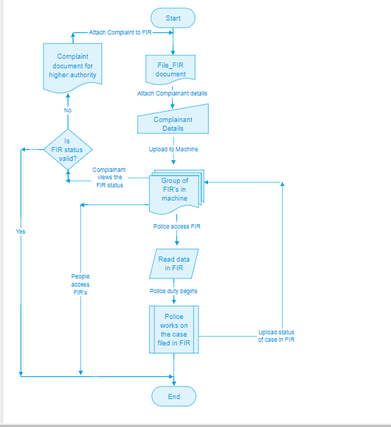

By allowing citizens to lodge their complaints directly, this system circumvents police officers who are often reluctant to register FIRs, particularly in kidnapping and ransom cases. Potentially, this could be an effective tool in combating the endemic corruption and pressure at the thana level. We have proposed to develop a system which provides an easily accessible web site which forms the front end and a web portal for the police department. The complaints would be registered over the web page. The complainant would be filling up the FIR form, he would be providing the proofs and details related to the complainant on the web page. The user can upload images, audio files, and video files as records. These details would then be received by the police officials on the web portal. They will verify the details of the complainant and carry out further proceedings of the case. The police officer will be posting the advancements made in the case into the account of the complainant through the portal. The user will receive updates in the form of notifications on his account. Thus the entire process would be carried out online, without much manual intervention.

PROTOTYPE:

The complainant fills out this form and click on next button.

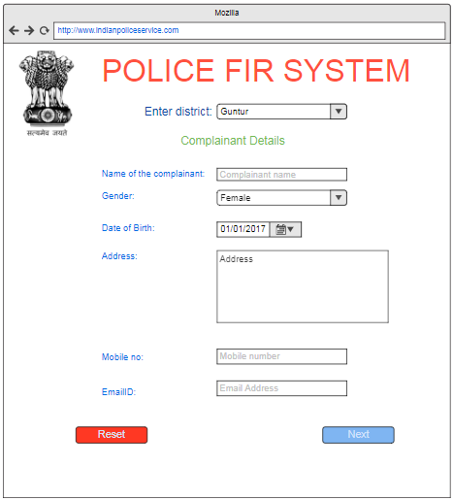

The next page asks for the details of complaint where we can give brief information about the case and upload audio or video files supporting the complaint.

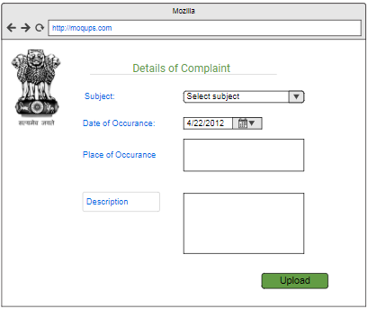

On clicking upload button the details of complaint and complainant are uploaded in to machine. The police registers by filling in the below form.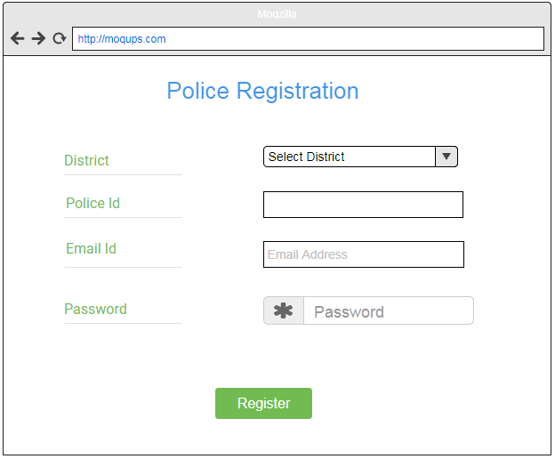

After registration, police can login to the website and gets the FIR’s posted by complainants of the specific district.

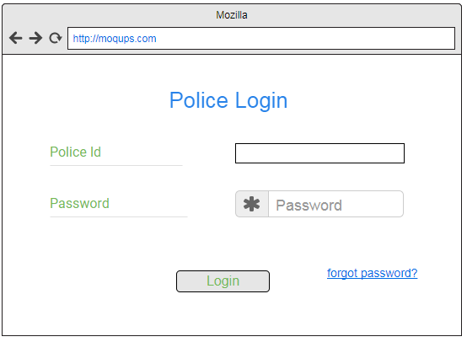

The list of FIR’s can be visible to police as below

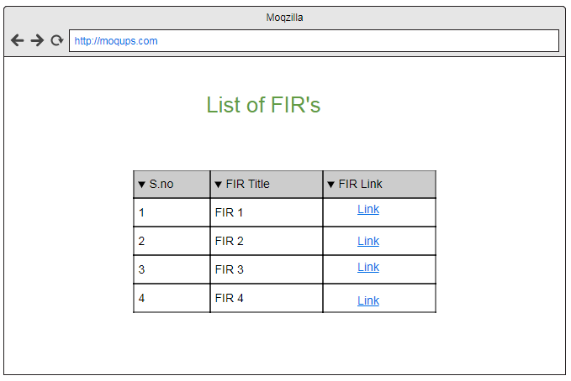

Police selects one FIR and starts investigation and submits police review in the below form. Police also upload the FIR status and if complainant feels it as invalid, complainant can file the report against police in charge.

